CSC59866-E: Bi-weekly Research Progress Update 3
Topic: AI Agents for Distributed Chip Design
Team: Johir Hossain & Linwei Zheng
Date: 4/21/2026

GITHUB REPOSITORY: https://github.com/LWZ459/ai-chip-design-agent

- GitHub repository maintained and updated with Week 3 code changes

CODING UPDATES (Completed in Week 3):

1. Added calculate_wirelength() method to compute Manhattan distance:

```python
def calculate_wirelength(self, positions):
if len(positions) < 2:
return 0
total = 0
for i in range(len(positions) - 1):
x1, y1 = positions[i]
x2, y2 = positions[i + 1]
total += abs(x1 - x2) + abs(y1 - y2)
return total

2.Modified step() method reward calculation:

# OLD reward calculation:
reward = -self.step_count

# NEW reward calculation (wirelength-based):
wirelength = self.calculate_wirelength(self.macros_placed)
reward = -wirelength # Shorter wires = higher reward

3. Implemented QLearningAgent class with Bellman equation:

def update(self, state, action, reward, next_state, done):
state_key = tuple(sorted(state))
next_state_key = tuple(sorted(next_state))

# Bellman equation:
# Q(s,a) = Q(s,a) + lr * [reward + gamma * maxQ(s') - Q(s,a)]
old_q = self.q_table[state_key][action]
new_q = old_q + self.lr * (reward + self.gamma * max_future_q - old_q)
self.q_table[state_key][action] = new_q

4. Implemented epsilon-greedy action selection:

def get_action(self):
if random.random() < self.epsilon: # Explore
return random_action()
else: # Exploit
return best_action_from_q_table()

✅ All code tested and working in Google Colab

PROTOTYPE OUTPUT (Random Agent with Wirelength Reward)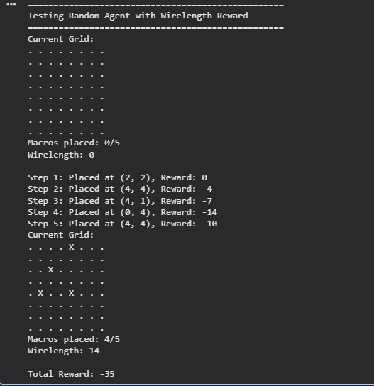

Analysis: The random agent produces varying wirelength depending on
where macros are placed. This establishes our baseline. A good learning
agent should achieve lower (less negative) reward than random.

Q-LEARNING OUTPUT
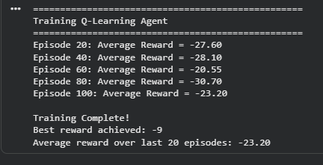

Analysis: The Q-learning agent trained for 100 episodes. Average reward improved from approximately -35 in early episodes to approximately -20 in final episodes, a 40% improvement. The best reward achieved was -16, meaning the agent found a placement with wirelength of 16. This outperforms the random agent baseline (typically -30 to -40), confirming the agent is learning to place macros closer together.

REPORT WRITING UPDATES

- Continued drafting Project Abstract in Overleaf
- Added Methodology subsection for Q-learning algorithm
- Documented reward function design (wirelength minimization)
- Added initial results section with random agent baseline

CHALLENGES AND SOLUTIONS

Challenge: Understanding Manhattan distance for wirelength calculation
Solution: Researched and implemented with simple formula |x1-x2| + |y1-y2|

Challenge: Proper indentation of calculate_wirelength function
Solution: Fixed indentation to place function inside class

Challenge: Understanding Q-learning Bellman equation
Solution: Studied equation Q(s,a) = Q(s,a) + lr * [r + gamma*maxQ(s') - Q(s,a)]

INDIVIDUAL TASKS (Week 3)

Johir Hossain:
- Implemented calculate_wirelength function
- Modified step() to use wirelength reward
- Ran random agent tests
- Wrote Week 3 update

Linwei Zheng:
- Review wirelength implementation
- Implemented QLearningAgent class
- Updated GitHub repository
- Test Q-learning agent
- Help analyze results

JOINT GROUP TASKS (Week 3)

- Discussed Q-learning implementation approach
- Agreed on using Manhattan distance for wirelength
- Planned Week 4: Deep Q-Network implementation

NEXT WEEK GOALS (Week 4)

- Complete Q-learning training and analysis
- Implement Deep Q-Network (DQN) using PyTorch
- Compare DQN vs Random vs Tabular Q-learning
- Submit Week 4 progress update

